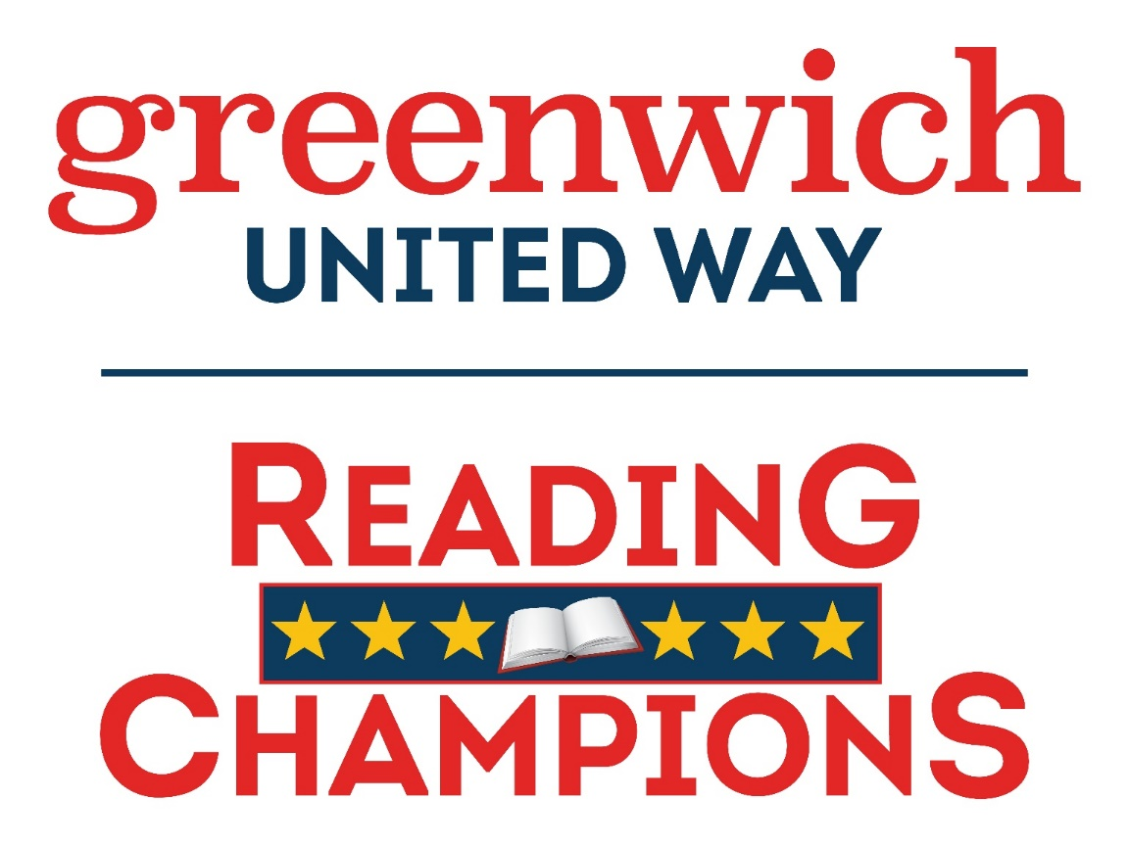

[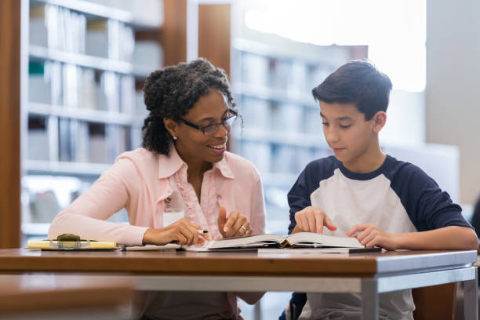](https://www.istockphoto.com/photo/tutor-working-with-middle-school-student-gm1130407049-298945914)

**About**

**Reading Champions:**

Entering its 15th year, the Greenwich United Way Reading Champions Program supports about 400 students annually across all Greenwich Public Elementary Schools and several after school programs in our community.

**What**

**Reading Champions Volunteers do:**

Volunteers support literacy and fluency growth with weekly 1-on-1 tutoring sessions.

Volunteers follow the Read Naturally curriculum to help students learn the skills they need to become fluent readers!

**Discover more about the program**

**by visiting:**

[**https://greenwichunitedway.org/reading-champions/**](https://greenwichunitedway.org/reading-champions/)

**Tuesday, September 20, 2022 12 pm–3pm**

**Literacy Summit &**

**Volunteer Open House**

**Greenwich Town Hall**

**101 Field Point Rd.**

**Greenwich, CT 06830**

**Learn how you can help build success and motivate young readers in our Greenwich community.**

**12pm: Guest Speakers: David Rabin, President & CEO of the Greenwich United Way, Kim Paladino, English Language Arts Coordinator K-8, Greenwich Public Schools**

Literacy Experts will share their insights about how Reading Champions helps our Greenwich community’s emerging readers achieve success. Volunteers will provide insight on their impact. Learn more about how your efforts make a lasting difference!

**1:30 - 3pm: Reading Champion Training & Volunteer Workshop**

Reading Champions Volunteers will receive training focused on successful techniques and best practices that help boost positive outcomes from tutoring sessions.

**\*For New and Returning Tutors\***

**Please RSVP by: September 10th, 2022**

[**cmeunier@GreenwichUnitedWay.org**](mailto:cmeunier@GreenwichUnitedWay.org) **or 203-829-2256**